**Web Mining Class Work : 03-02-2023**

**Name: Aryan Vigyat**

**Registration Number: 20BCE1452**

**Suffix Trees**

Question 1;

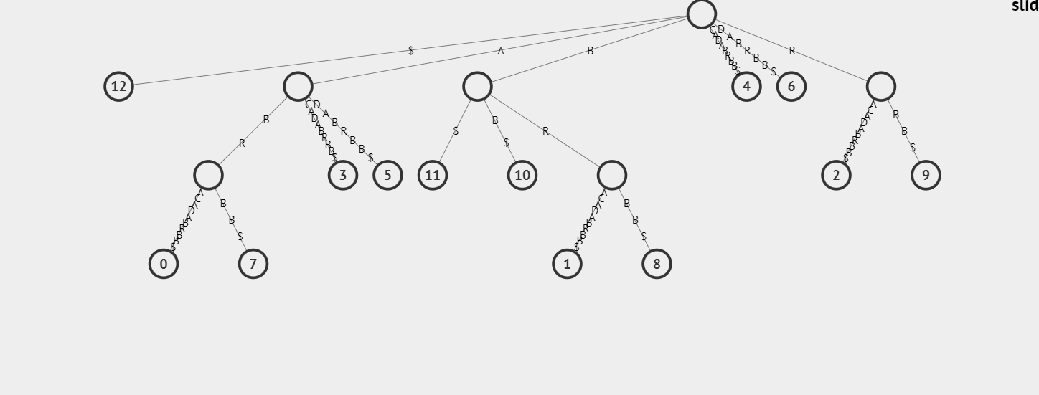

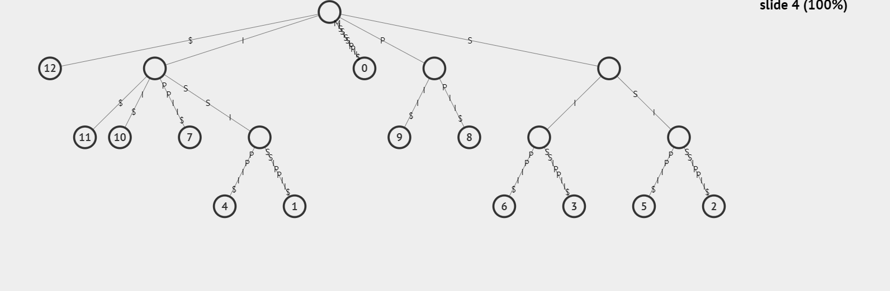

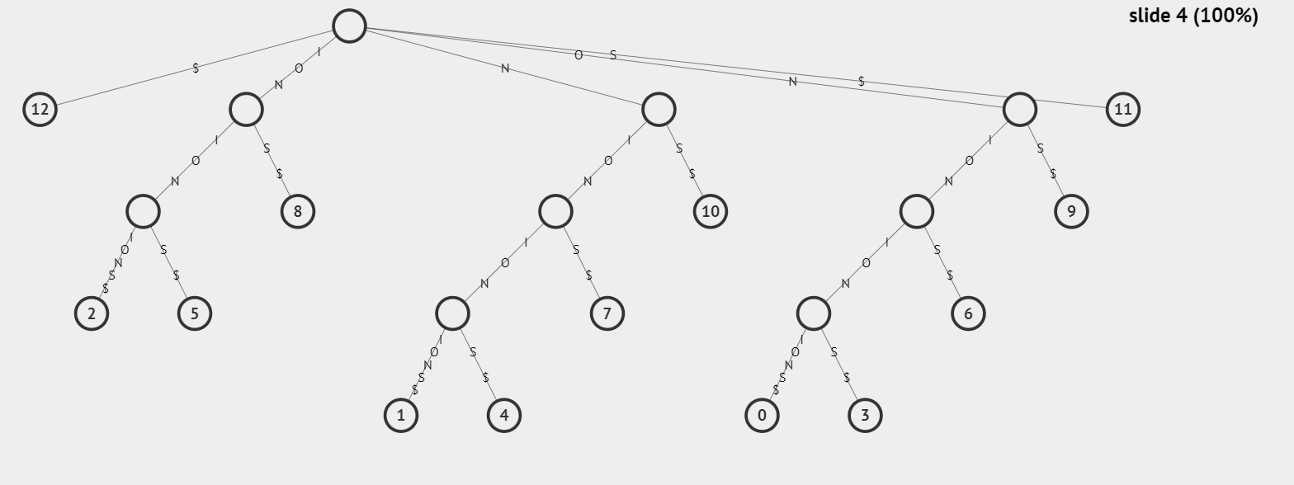

For 1st text

Search Results:

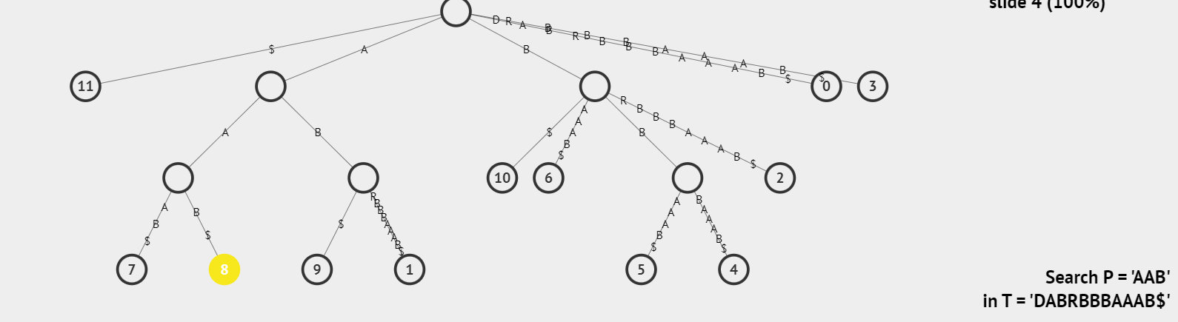

Longest Repeated Substring

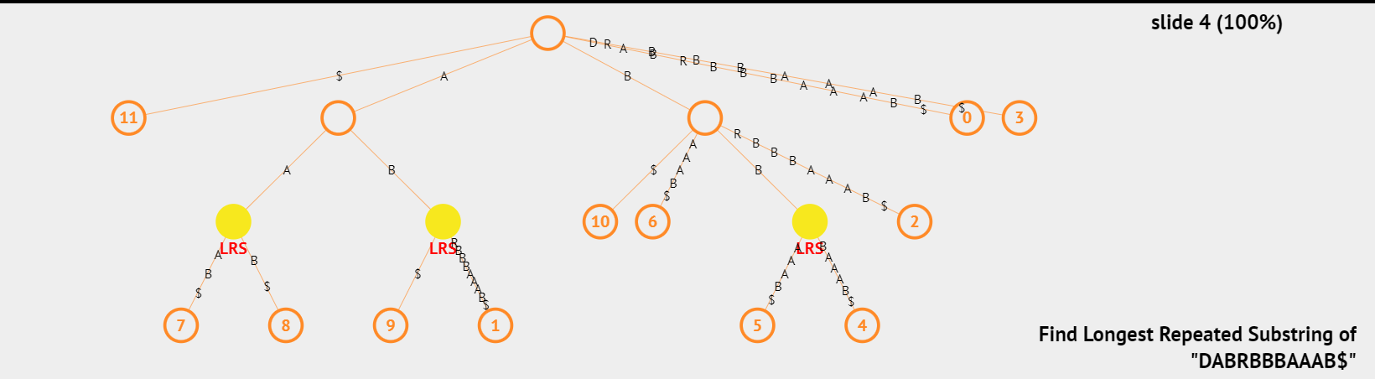

Longest Common Substring

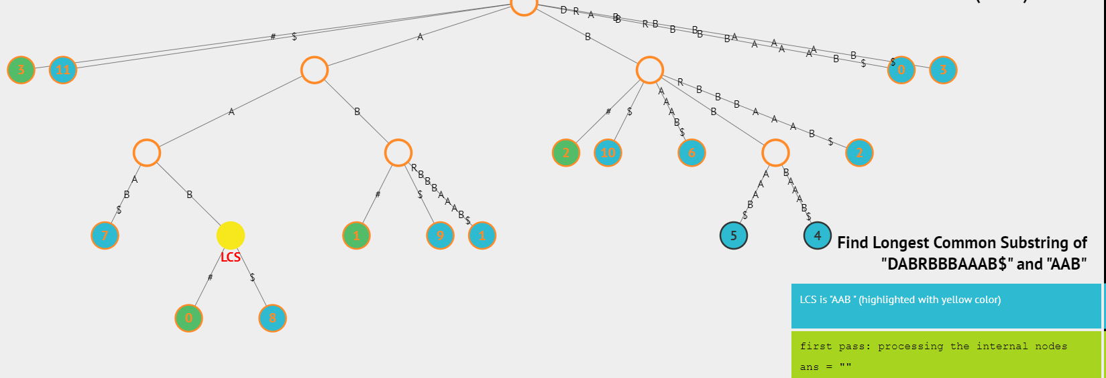

For 2nd Text

Search Results

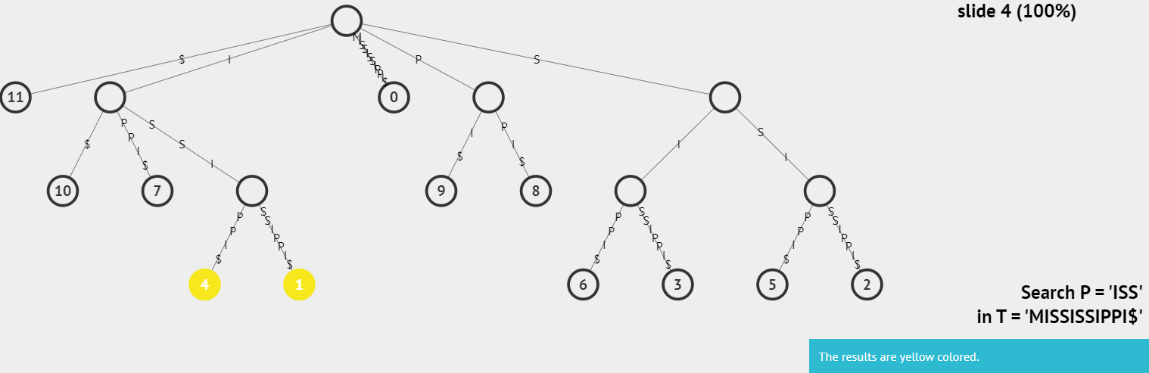

Longest Repeated Substring

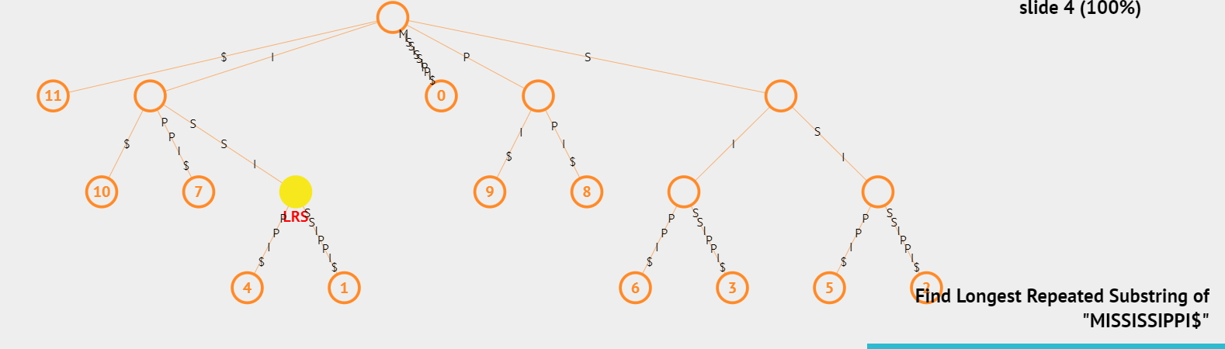

Longest Common Substring

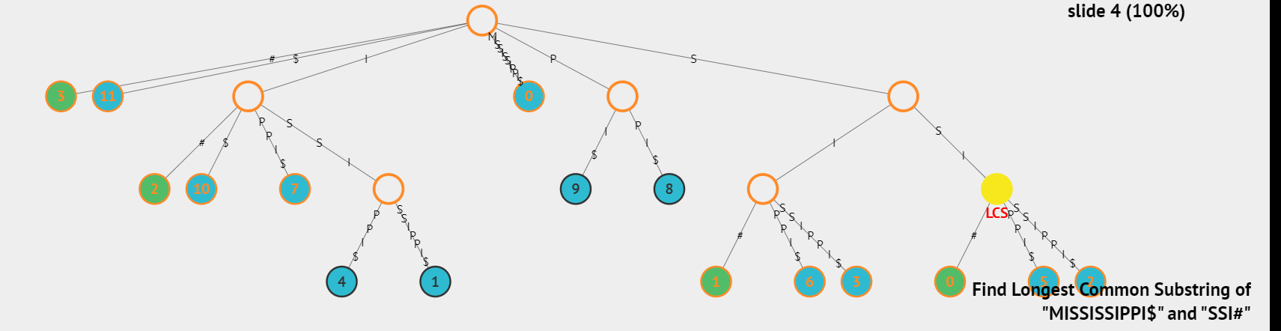

For 3rd Text

Search Results

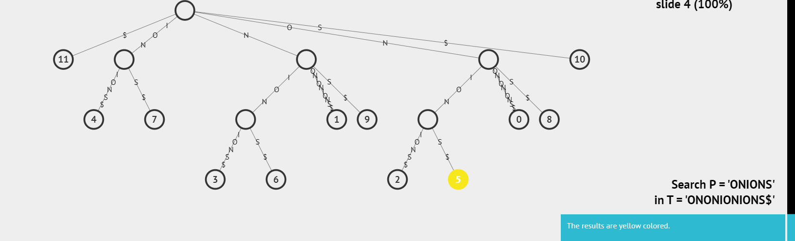

Longest Repeated Substring

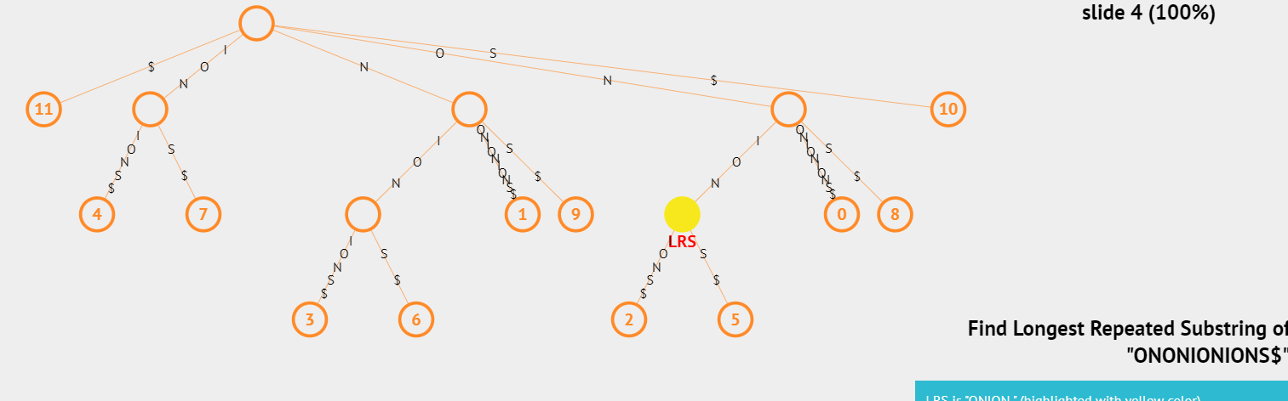

Longest Common Substring

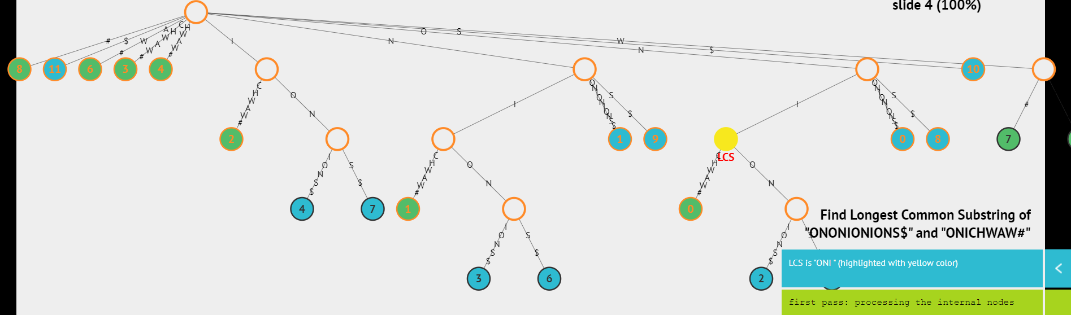

Question 2

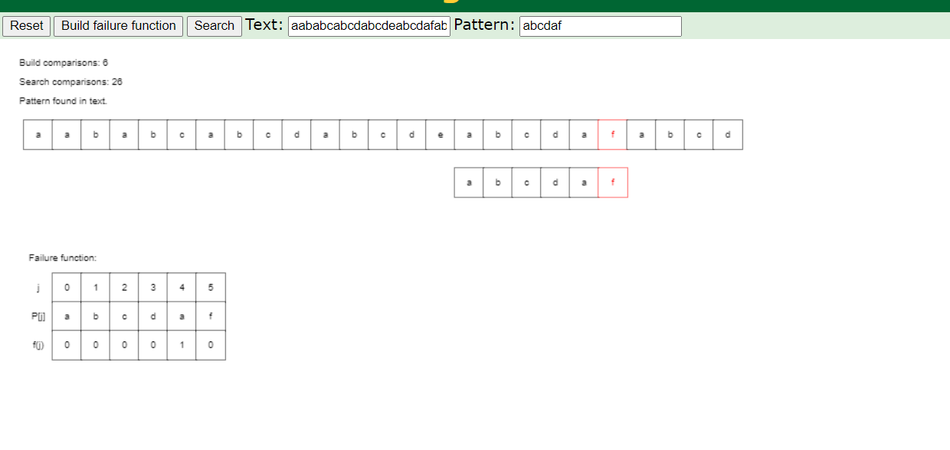

Time Complexity of KMP is 0(n)

Question 3

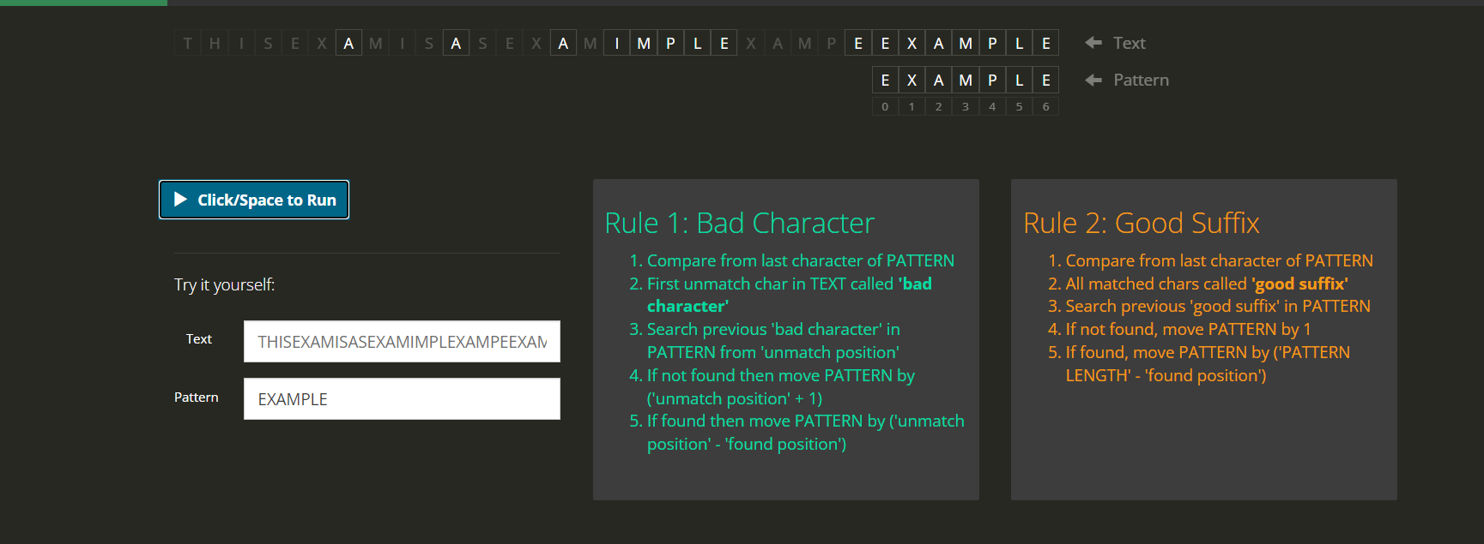

The time complexity of the Boyer-Moore algorithm depends on the input, so in this case, the algorithm will have a time complexity of O(n/m) on average, where n is the length of the text (28 in this case) and m is the length of the pattern (7 in this case). The exact time complexity would depend on various factors such as the implementation and the way the algorithm is designed to handle specific patterns.